Tufts CTSI Dissemination and Implementation Science Core
Disseminate the Findings: Dissemination Planning Template

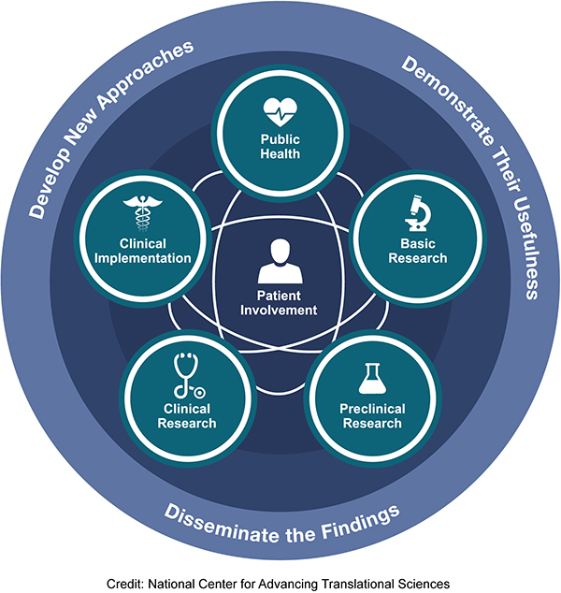
Translational science and dissemination planning
Planning for dissemination is essential in all stages of research. The graphic below displays the three key stages of research across the translational spectrum: 1) Develop new approaches, 2) Demonstrate their usefulness, and 3) Disseminate the findings. This worksheet is designed to help you plan for dissemination, regardless of the stage your work along the translational science spectrum.
A dissemination plan typically includes strategies for sharing innovations (research findings, interventions, best practices) with relevant audiences. Having a dissemination plan helps to maximize the impact of the work by ensuring that it reaches the relevant stakeholders and encourages adoption and implementation. Answering the following questions about your project can help you ensure that you have all 10 essential elements in your dissemination plan.

Common dissemination plan elements:
Project title:
Innovation or intervention (research finding or best practice):
Are you adapting this innovation or intervention from another CTSA?
- Objectives: Clearly define the goals and objectives of the dissemination plan. What do you aim to achieve by sharing your innovation or best practice?

- Target audience: Identify the specific individuals or groups who would benefit from your innovation. Consider academics, practitioners, policymakers, industry professionals, communities, and the general public. This should include individuals, groups, and organizations that will be using the innovation or will be in a position to support dissemination.

- Key messages: Determine the main findings, insights, or recommendations you want to communicate to your target audience. Condense your findings or innovation into clear and concise messages. Consider using plain language at an 8th grade reading level for lay audiences.

- Communication channels: Select the appropriate channels for disseminating your information. These can include academic journals, conferences, seminars, types of educational activities, press releases, websites, blogs, social media platforms, newsletters, and traditional media outlets. Timing and sequencing: plan the timing and sequence of your dissemination activities. Consider whether you want to release preliminary findings or wait until the project is fully completed and published.

- Collaboration and partnerships: Identify potential collaborators or partners who can help amplify the reach of your information. This could involve working with organizations, institutions, or influential individuals who share similar interests or can support your dissemination efforts.

- Dissemination materials: Prepare appropriate materials to support the communication of your information including research papers, executive summaries, infographics, implementation guides, slide decks, videos, podcasts, or other media formats.

- Evaluation and tracking: Develop methods to assess the effectiveness of your dissemination efforts. This could involve tracking metrics such as reach, engagement, citations, media coverage, or feedback from your target audience.

- Budget and resources: Consider the resources required to implement your dissemination plan. Allocate budgetary resources and identify personnel responsible for executing the plan.

- Ethical considerations: Take into account ethical guidelines related to research dissemination, including issues of privacy, confidentiality, intellectual property rights, and informed consent.

- Long-term engagement: Consider if and how you can maintain ongoing engagement with your target audience beyond the initial dissemination. This may involve follow-up activities, collaborations, or opportunities for further dialogue and knowledge exchange.

Tufts CTSI D&I Core
Would you like more information or help to develop a dissemination plan? Please submit a service request via the Tufts CTSI website.
Last updated by Tufts CTSI D&I Core: November 30, 2023

